Day 3
Task 1

Command 1: ip addr — Display IP Addresses

Purpose: Displays network interfaces and their assigned IP addresses.
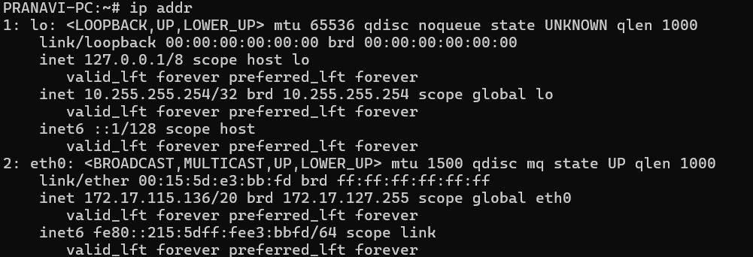

Command 2: ip route — View Routing Table
Purpose: Displays the routing table and identifies the default gateway used to reach other networks.
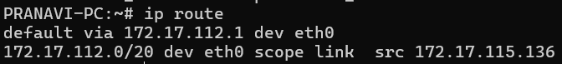

Command 3: ping -c 4 google.com — Test Network Connectivity
Purpose: Sends four packets to Google to check whether the destination responds and to measure network delay.
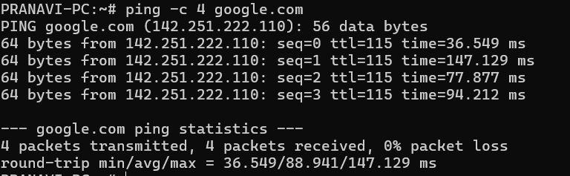

Command 4: ip link — Check Network Interfaces
Purpose: Displays network interfaces and their status, such as whether an interface is up or down.
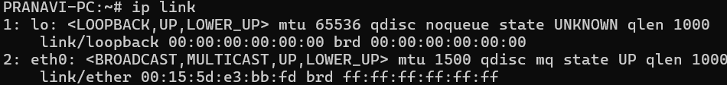

Command 5: hostname -I — Display Machine IP Addresses
Purpose: Displays the IP addresses assigned to the current machine.
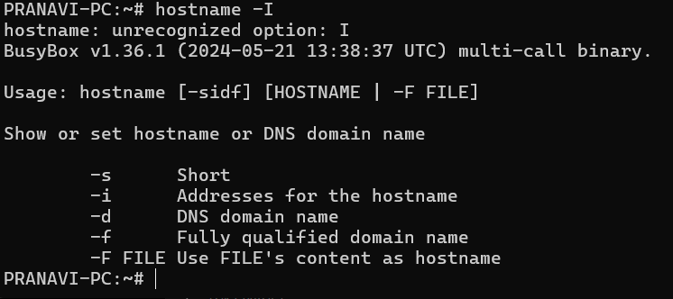
Command 6: ip neigh — View Network Neighbors
Purpose: Displays information about nearby devices discovered on the local network using ARP or IPv6 Neighbor Discovery.
Command 7: ss -tuln — View Listening Ports
Purpose: Lists listening TCP and UDP sockets to help identify services waiting for network connections.
Command 8: traceroute google.com — Trace Network Route
Purpose: Shows the network hops that packets attempt to travel through to reach Google.
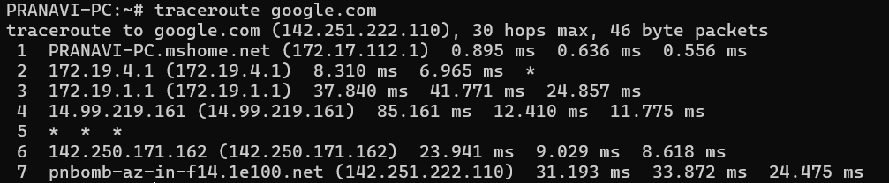
Command 9: getent hosts google.com — Resolve Domain Names
Purpose: Checks whether the system can resolve a domain name into an IP address using its configured name-resolution services.

Command 10: curl -I https://google.com — Check HTTP Response Headers
Purpose: Sends an HTTP HEAD request and displays the response headers to check whether a website can be reached over HTTPS.

